**Ideation Phase**

**Define the Problem Statements**

|  |  |
| --- | --- |
| Date | 19 September 2022 |
| Team ID | **PNT2022TMID43088** |
| Project Name | Project - Customer Care Registry |
| Maximum Marks | 2 Marks |

**Problem Statement:**

I am Surya and I am a regular customer in famous e-commerce websites like Amazon, Flipkart. I order regularly. The problem I have is that in most times, I don’t have any reliable sources to clear my doubts in some of the products I buy.

There are reviews and customer ratings in those websites, but somehow, I don’t feel they are authentic and real. It would make my world if those replies were from a real expert, and I could clarify all my doubts in a single platform. Of course, I would need instant replies from a real expert who knows about the products I am asking for.

**Example:**

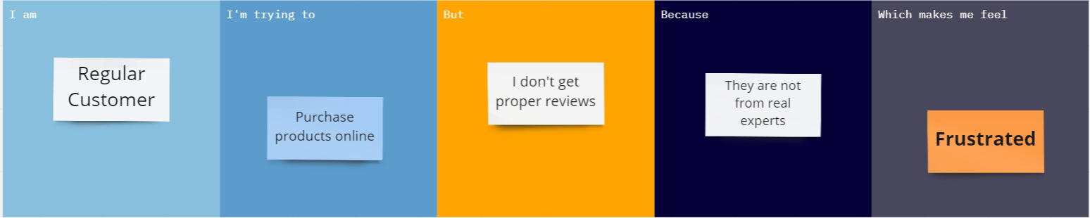

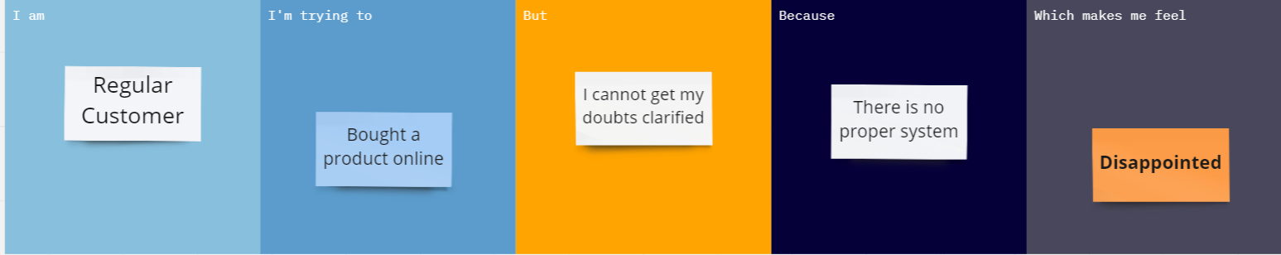

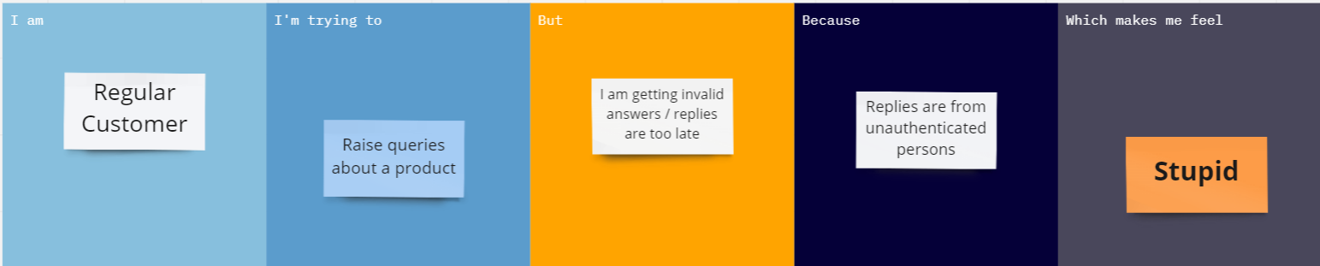

|  |  |  |  |  |  |
| --- | --- | --- | --- | --- | --- |
| **Problem Statement (PS)** | **I am (Customer)** | **I’m trying to** | **But** | **Because** | **Which makes me feel** |
| PS-1 | Regular Customer | Purchase products online | I don’t get proper reviews | They are not from real experts. | Frustrated |
| PS-2 | Regular Customer | Bought a product | I cannot get my doubts clarified | There is no proper system | Disappointed |
| PS-3 | Regular customer | Raise queries about a product | I am getting invalid answers /  replies are too late | Replies are from unauthenticated  persons | Stupid |
|  | | | | | |